Burnout to Brilliance: A Year-End Reset for Leaders
Part 1: Pause with Purpose
What fueled you this year—and what drained you?
Use this space to reflect on the highs and lows, the wins and the weariness.
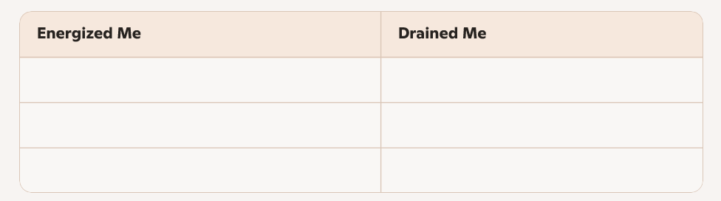
Part 2: Reclaim Your Rituals
What routines helped you feel grounded, creative, or clear-headed?
Circle what you want to bring back—or build anew—in 2026.
☐ Morning walks
☐ Journaling
☐ Creative play
☐ Quiet coffee time
☐ Weekly planning ritual
☐ [Your own ritual] _______________________

Part 3: Redefine Success
Let go of the “finish strong” pressure. What does finishing aligned look like for you?
Write a few thoughts or a mantra to guide your final weeks of the year.
In 2026, I want to feel more __________ and less __________.
My new definition of success includes: ___________________________

Part 4: Lead with Humanity
How will you model renewal and reflection for your team or clients?
Use this space to jot down ideas for meaningful conversations, acknowledgments, or culture cues.
- I want to share this reflection with: ____________________
- I’ll invite my team to reflect by: ______________________
- One way I’ll show up real this season: ___________________

Final Prompt:
What’s one word you want to carry into 2026?
(Write it big. Make it yours.)
My word: ___________________

